

A Project Report

On

**Solution for effective utilization of coir raw material to avoid wastage**

Batch Details

|  |  |  |
| --- | --- | --- |
| Sl. No. | Roll Number | Student Name |
| 1 | 20211CST0006 | Nagaruru Sunandhan |
| 2 | 20211CST0039 | Bobbiti Yaswanth Reddy |
| 3 | 20211CST0041 | Kruthika S |

**School of Computer Science,**

**Presidency University, Bengaluru.**

Under the guidance of,

Mrs. Shaik Salma Begum

School of Computer Science,

Presidency University, Bengaluru

**Name of the Program:** Btech

**Name of the HoD:** Dr. Saira Banu Atham

**Name of the Reviewer:** Dr. Saira Banu Atham

**Name of the Program Project Coordinator:** Dr. H M Manjula

**Name of the School Project Coordinators:** Dr. Abdul Khadar A

**CONTENTS**

1. Introduction about Project
2. Literature Review
3. Objectives

## Methodology

1. Timeline for Execution of Project
2. Expected Outcomes
3. Conclusion
4. References
5. **INTRODUCTION**

Coir is a biodegradable natural fiber obtained from the husks of coconuts, widely recognized for its eco-friendly nature and versatility. It is primarily used in industries such as construction, agriculture, textiles, and environmental remediation. In the construction sector, coir is employed as reinforcement material in cement-based products, contributing to sustainable building practices. In agriculture, its excellent water retention properties make it suitable for hydroponics and soil conditioning. In the textile industry, advancements in fiber processing allow coir to be transformed into durable fabrics. Coir is also used to produce eco-friendly products such as mattresses, mats, brushes, ropes, biofuels, and activated carbon.

Despite its broad applications, the coir industry faces several challenges, including inefficient resource management, wastage of raw materials, and a lack of communication between stakeholders. These issues limit the economic potential of coir and hinder efforts to reduce environmental waste.

1. **LITERATURE REVIEW**
2. Utilization of waste coir fibre architecture to synthesize porous graphene oxide and their derivatives Krishna K. Yadav, Harish Singh, Supriya Rana (2020)

* Advantage: The conversion of low-value coir fibre into high-value graphene oxide promotes sustainable waste management and cleaner production.
* Disadvantage: The complexity of the chemical processes involved may limit large-scale application.

1. Uptake of dyes by a promising locally available agricultural solid waste Namasivayam, R. Radhika (2000)

* Advantage: The use of coir pith provides an economical solution for wastewater treatment, especially in developing countries.
* Disadvantage: The need for carbonization and specific pH conditions adds complexity to its practical application.

1. Utilization of coconut waste for production of activated carbon and its application as a low-cost adsorbent in environment treatment Hoang,Thi Cam Quyen Ngo (2023)

* Advantage: Coconut-based activated carbon offers a sustainable, low-cost material for environmental treatment.
* Disadvantage: High activation temperatures (>500°C) and the use of strong acids (H3PO4, H2SO4) might present environmental and safety concerns.

1. A state-of-the-art review on coir fiber-reinforced biocomposites Hasan, Miklos Bak, Tibor Alpar​ (2021)

* Advantage: Coir biocomposites are eco-friendly and provide superior durability, making them an excellent alternative to synthetic composites.
* Disadvantage: The inhomogeneous characteristics of coir fibers can result in variable performance of the biocomposites.

1. Effective utilization of natural fibres (coir and jute) for sustainable low-volume rural road construction Nitish Kumar, Ramesh K. Kandasami, (2022)

* Advantage: Utilizing coir geotextiles in road construction is a cost-effective and sustainable method, particularly for rural areas.
* Disadvantage: The moisture-absorbing nature of coir fibers may reduce their long-term effectiveness unless adequately treated.

1. Coir Geotextile-Packed Conduits for Wastewater Treatment A. Praveen, P. B. Sreelakshmy 2008

* Advantage: The use of coir geotextile is cost-effective and eco-friendly.
* Disadvantage: Requires careful monitoring of operational conditions to ensure effective treatment.

1. Physical and Chemical Properties of Coir Waste and Plant Growth P. Noguera, M. Abad 1997

* Advantage: High porosity improves air circulation for plants.
* Disadvantage: Needs additional treatments to reduce salinity levels.

1. Coir from Coconut Processing Waste: Applications Beyond Traditional Uses. Wolfgang Stelte, Narendra Reddy2022

* Advantage: Promotes sustainability by reducing agricultural waste.
* Disadvantage: Some applications require complex processing techniques, increasing production costs.

1. **OBJECTIVES**

1.Manage and Track Coir Raw Materials

* The project aims to address the challenge of inefficient tracking of coir resources by creating a centralized system. This system will allow farmers to register and update the availability of their coir stock in real-time, ensuring that industries can access up-to-date information. Effective tracking ensures better control over stock levels and prevents valuable raw materials from being overlooked or wasted.

2.Reduce Coir Raw Material Wastage

* A significant amount of coir material is discarded due to a lack of market awareness and poor planning. This platform aims to reduce waste by aligning supply with demand more efficiently. By making coir stocks visible to industries as soon as they become available, the platform will reduce the dumping of unused materials into landfills. Proper allocation ensures that raw material is utilized in productive ways, such as in construction, textiles, agriculture, or biofuel production.

3.Improve Resource Allocation

* The project seeks to solve the problem of mismatched resource allocation—where some areas experience surplus while others face shortages. Using the platform, industries can search for specific coir products (e.g., fibers or coir pith) and place orders according to their needs. Real-time data and predictive analytics will help optimize resource allocation across different sectors, ensuring that available materials are efficiently distributed and utilized.

4.Streamline Transactions

* Currently, transactions between farmers and industries are inefficient and time-consuming due to the lack of a direct communication channel. The platform will automate and simplify the transaction process, reducing delays. Industries will be able to place orders directly through the system, and farmers will receive instant notifications about new demands. Automatic transaction logging ensures that both parties can track their orders and payments, saving time and improving efficiency.

1. **EXPERIMENTAL DETAILS/METHDOLOGY**
2. **Software Requirements:**

**VS Code**: As the integrated development environment (IDE) for writing and managing code.

**Django**: A Python-based web framework to handle the back-end, including routing, data

management, and user authentication.

**MySQL**: For storing user data, raw material availability, and transaction records in a relational

database.

**2. Technology Stack Components:**

**Frontend :**

Uses HTML for structure, CSS for styling, JavaScript for interactivity, and Bootstrap for responsive design. VS Code is the IDE for efficient development and management of both frontend and backend components.

**Backend :**

Django, a Python web framework, to manage core functionalities like user registration, data entry by farmers, real-time coir availability tracking, transaction recording, and data access for analytical firms. Python ensures efficient data manipulation and scalability, while Django provides built-in security features like CSRF protection, input validation, and secure password storage.

**Database (SQLite/PostgreSQL/MySQL)**:

SQLite is used for development due to its lightweight and easy setup, storing user, coir availability, and transaction data. For production, MySQL/PostgreSQL provide more robust solutions, efficiently handling large volumes of data and multiple concurrent requests.

**User Authentication (Django Authentication System):**

Django’s built-in authentication system manages secure logins, password handling, and session management. It ensures that users have the correct permissions and provides a scalable solution for maintaining data privacy and access control.

**SMS API (Twilio/Vonage Messages API):**

The Twilio/Vonage API integrates SMS functionality, allowing farmers to update coir data via SMS and industries to receive real-time notifications. This ensures communication even for users with limited internet access.

**Version Control (Git and GitHub):**

Git tracks code changes and enables collaboration, while GitHub hosts the project’s repository. GitHub provides tools for collaboration, backup, issue tracking, and task management, ensuring smooth project development and version control.

**4. METHODOLOGY**

* **User Management Module :** Manage user registrations, authentication, and roles.
* **Technology used :** HTML, CSS and javascript for user registration/login forms, Django Allauth for authentication, SQL for user data storage.
* **Coir Stock Management Module :** Allow farmers and industrialists to input and update their coir stock information.
* **Technology used :** HTML and CSS for stock input/update forms, Django REST framework for API, Twilio for SMS integration, SQL for stock data storage.
* **Industry Requests Module :** Enables industries to accept selling requests of coir materials from different farmers.
* **Technology used :** Bootstrap for real-time selling requests, Django REST framework for request handling.
* **Transaction Module** : Keeps recent transaction information of users.
* **Technology used :** Django to manage transaction logic, SQL for transaction storage.
* **Data Analytics and Reporting Module** : Provide analytics on stock levels and usage trends to help industries make informed decisions.
* **Technology used :** Django with Pandas for data analysis, D3.js or Chart.js for visualizations, SQL for analytical data storage.
* **Feedback Module :** Allow users to send feedbacks of website.
* **Technology used :** HTML and CSS for feedback forms, Django for form handling, SQL for storing feedback.

1. **OUTCOMES**

* **Efficient Coir Utilization:** Minimized wastage of coir raw material through real-time tracking.
* **Increased Farmer Revenue:** Farmers can directly sell to industries, maximizing their earnings.
* **Expanded Market Reach:** Farmers can access buyers beyond their local region.
* **Transparency in Transactions:** Valid ID verification ensures transparency in all deals.
* **Reduced Middlemen Dependency:** Direct farmer-to-industry sales eliminate unnecessary intermediaries.
* **Time and Cost Savings:** Farmers and industries save time by using the platform for transactions.
* **Improved Decision-Making:** Data analytics firms get organized transaction data for insights.
* **Data-Driven Insights:** Data analytics firms can use detailed transaction data for market studies.
* **Sustainable Practices:** Optimized use of coir supports eco-friendly industry practices.
* **Real-Time Market Access**: Industries access real-time data on raw material availability.
* **Accurate Forecasting**: Industries and analysts can better forecast raw material trends.
* **Transaction Security**: Automated saving of transaction records ensures accountability.

**6. TIMELINE OF THE PROJECT/ PROJECT EXECUTION PLAN** 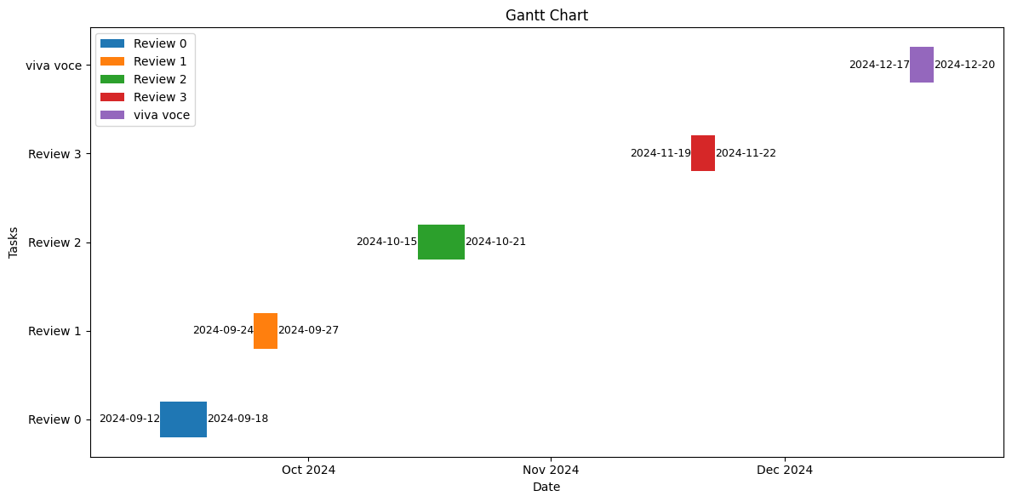

**7. CONCLUSION**

The proposed website for effective utilization of coir raw materials serves as a vital platform connecting farmers, industry personnel, and data analytical firms. By offering real-time updates, transaction management, and a centralized database, it fosters transparency and reduces wastage in the coir industry. Through seamless web and SMS-based data input, farmers can easily update material availability, while industry owners can efficiently track and source raw materials. The platform also facilitates data-driven insights for analytical firms, aiding in industry analysis and planning. Ultimately, this platform ensures that coir raw materials are optimally used, benefiting both the environment and the economy by minimizing resource wastage and maximizing productivity.

1. **REFERENCES**

* Coconut coir waste, a new and viable ecologically- Friendly peat substitute <https://www.researchgate.net/publication/286988277_Coconut_coir_waste_a_new_and_viable_ecologically-_Friendly_peat_substitute>
* Coir geotextile-packed conduits for the removal of biodegradable matter from wastewater <https://www.jstor.org/stable/24102806>
* Coir from Coconut Processing Waste as a Raw Material for Applications beyond Traditional Uses <https://www.researchgate.net/publication/365419789_Coir_from_coconut_processing_waste_as_a_raw_material_for_applications_beyond_traditional_uses>
* Effective utilization of natural fibres (coir and jute) for sustainable low-volume rural road construction <https://www.sciencedirect.com/science/article/abs/pii/S0950061822022632>
* Coir from Coconut Processing Waste as a Raw Material for Applications beyond Traditional Uses <https://researchprofiles.ku.dk/en/publications/coir-from-coconut-processing-waste-as-a-raw-material-for-applicat>
* A state-of-the-art review on coir fiber-reinforced biocomposites <https://pubs.rsc.org/en/content/articlelanding/2021/ra/d1ra00231g>
* Utilization of coconut waste for production of activated carbon and its application as a low-cost adsorbent in environment treatment <https://pubs.aip.org/aip/acp/article-abstract/2943/1/030006/2931471/Utilization-of-coconut-waste-for-production-of?redirectedFrom=fulltext>
* Uptake of dyes by a promising locally available agricultural solid waste <https://www.sciencedirect.com/science/article/abs/pii/S0956053X00000817>
* Utilization of waste coir fibre architecture to synthesize porous graphene oxide and their derivatives <https://www.sciencedirect.com/science/article/abs/pii/S0959652620342852>
* PHYSICAL AND CHEMICAL PROPERTIES OF COIR WASTE AND THEIR RELATION TO PLANT GROWTH <https://www.actahort.org/books/450/450_45.htm>
* Coir geotextile-packed conduits for the removal of biodegradable matter from wastewater <https://www.jstor.org/stable/24102806>